
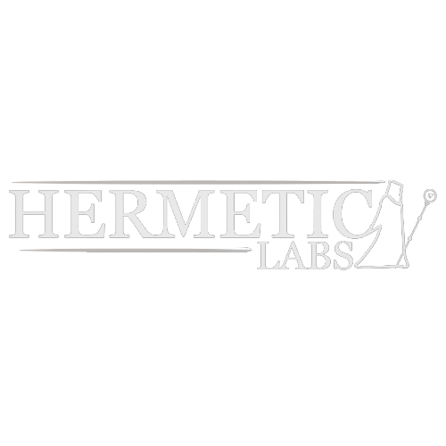

Hermetic Labs LLC — Capability Statement
“Do it. Do it Right. Do it Right Now.”

Core Competencies
• XR/VR Training Systems. Unreal Engine–based immersive environments for task training and scenario rehearsal — built on a AAA-grade real-time modeling pipeline that ensures both visual fidelity and performance at scale.
• Procedural Content & Pipelines. Proprietary content-generation tools accelerate asset creation, scenario branching, and environment variation — enabling rapid prototyping and efficient sustainment.
• API Development & Integration. Experience building, extending, and integrating APIs to connect simulation systems with analytics dashboards, training records, and external enterprise tools.
• Hardware–Software Prototyping. In-house development of custom controllers, sensors, and devices (VRF framework, Jumbo Jim emergency entry tool), ensuring seamless interaction between digital and physical systems.
• Operational Experience. Proven ability to manage and scale a national business for 15 years, demonstrating capacity for delivery, compliance, and sustained support in government and commercial markets.

Differentiators
• High-Fidelity, Lean Delivery. We achieve enterprise-grade realism while operating with the speed and adaptability of a small team — enabling rapid iteration without sacrificing quality.
• Full In-House Pipeline. From concept through R&D, software, hardware fabrication, and testing, we handle the entire lifecycle internally, scaling scope without heavy reliance on subcontractors.
• Cross-Domain Expertise. Our portfolio spans XR training systems, applied sciences, and hardware fabrication — giving us perspectives and solutions that cross traditional silos.
• Our Ethos. We do the ordinary, extraordinarily well. We see the whole stream — designing solutions that don’t just treat symptoms, but aim to eliminate the conditions that created the problem.
• Bespoke Immersion Techniques. We specialize in crafting tailored experiences that superimpose presence, data, and physics into intuitive, memorable environments — producing training that feels natural, impactful, and unique.

Past Performance
• Prototype Portfolio (Fabrication & XR). Developed multiple applied prototypes — including the Jumbo Jim emergency entry tool and custom XR simulation environments — demonstrating the ability to move from concept to functional deliverable.
• Product Design & Fabrication. Operated a storefront on Fab.com, delivering bespoke hardware and design products to a national customer base. Demonstrated ability to take concepts through design, fabrication, marketing, and fulfillment at scale.
• Intellectual Property Development. Filed provisional patents in procedural simulation techniques and adaptive training interfaces; one full patent currently under review.
• Operational Track Record. Successfully owned and operated a national business for 15 years, managing delivery, compliance, and growth — establishing a foundation of reliability and organizational discipline.

Company Data
- Legal name: Hermetic Labs LLC
- Primary contact: Dwayne Tillman (CEO & Founder)
- Employees: 2 (Dwayne Tillman and spouse)
- EIN: 39-3166825
- UEI/DUNS: 13-381-9314
- CAGE code: 148C3
- Business size: Small (self-certified via SAM.gov)
- Primary address: 100 Fieldstone Way, Fayetteville, GA 30215【442†source】
- NAICS codes: 541511, 541512, 541715, 541990, 611710, 611420/611430, 332999, 339112 / 334511

Contact
For inquiries or teaming opportunities:
Dwayne Tillman, CEO & Founder Email: DwayneTillman@7HermeticLabs.Dev

Hermetic Labs LLC is a registered small business on SAM.gov and Exostar, ready to partner with primes and federal agencies on simulation, training, rehabilitation, and educational projects. We embrace a “Do it. Do it Right. Do it Right Now.” ethos, combining quality, agility, and urgency in everything we build.

